EYFS Curriculum at Madginford Primary School
What will we be learning this year?
Autumn |  | Spring |  | Summer
Marvellous Me |  | My Wonderful World |  | Let’s Go Exploring
New Beginnings | Changes & Celebrations | People & Cultures | From a Tiny Seed | All Creatures Great & Small | Land Before Me
Starting school is a big adventure and we learn about being good friends, working together and what happens in a classroom.  As red, brown and golden colours arrive all around us, we explore Autumn, before developing our understanding of the Christmas story and how Christmas is celebrated. |  | We think about where we live and find out about the people in our community who help us. We then learn about different cultures and how they celebrate.  Spring is a brilliant time of year when everything seems to burst into life – we look at things that grow. It’s amazing what you can learn when you look really carefully. |  | We explore the living world around us including animals, from minibeasts to huge animals, including prehistoric dinosaurs and the habitats of all of these animals. We find out about pets through our special visitors!  We continue to learn about ‘long ago’ looking at traditional tales and castles.
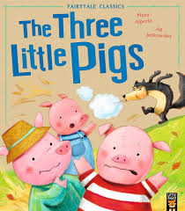
Here are just some of the brilliant books that help us on our journey…


