Madginford Primary School Newsletter
Friday 3rd July 2026

From the Headteacher – Mrs A. Woolcombe
Our children continue to impress us with their hard work, enthusiasm and positive attitude, and we are incredibly proud of every one of them.
This week, both our Year 1 and Year 5 children had a fantastic time on their school trips. A huge thank you to all the parents and carers who generously gave their time to support these visits—we really couldn't do it without you!
As we head towards the end of the term, we have lots of exciting events to look forward to. We can't wait to share these special moments with our children and families over the coming weeks.

Friends of Madginford

We are excited to invite you to become part of the Friends of Madginford Primary School; a new fundraising group dedicated to supporting our school community and helping provide extra opportunities and resources for our children.
Our aim is to bring together parents, carers, staff, and local supporters to organise fundraising events, social activities, and community projects that will benefit the school and enrich the children’s learning experience.

We would love for as many people as possible to get involved, whether by joining the committee, helping at events, sharing ideas, or simply supporting activities throughout the year.
Thank you very much to those who have come forward so far to volunteer; we cannot wait to see the fantatsic things which you wil help to do for our school.

Our initial meeting will take place on Friday 17th July at 09:00. Refreshments will be provided. Please let usk now if you are able to attend by emailing office@mps.kent.sch.uk

If you would like more information on our Friends of Madginford intiiative, or to rgister your interest, please get in touch via our office email address: office@mps.kent.sch.uk

Heatwave Update

Last week saw us all feeling the heat- quite literally!
We are incredibly proud of how our staff and children helped to keep each other safe and cool during the soaring temperatures. For some lucky children, this meant an impromptu Spa afternoon where they got to enjoy keeping their feet fresh whilst learning and having fun!

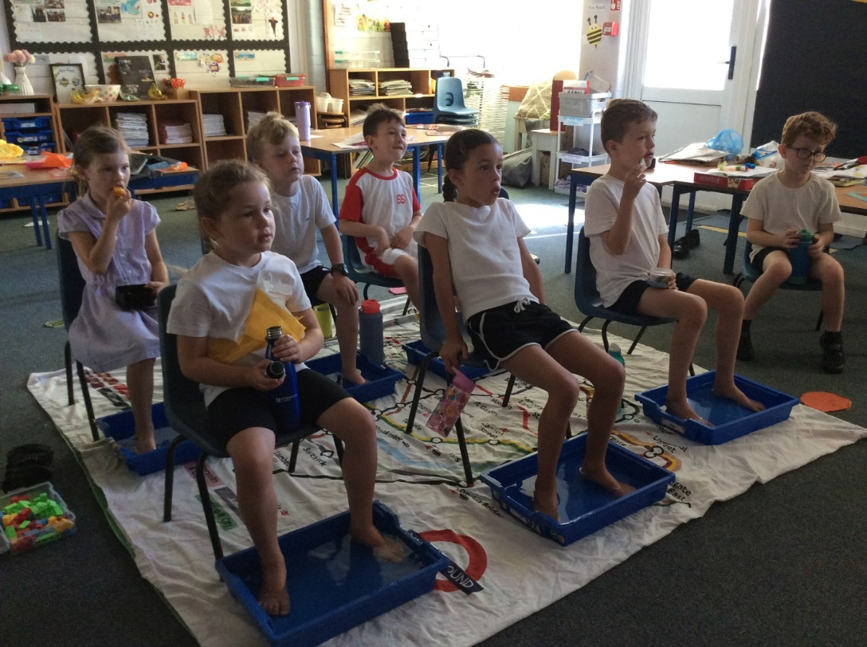

EYFS - celebration of learning - Wednesday 15th July 2:45pm

We would like to welcome parents and carers into the classroom to see the progress that the children have made since starting school in September. We do this by showing you the 'Look what I can Do' books they completed then and in comparison, the ones that have completed recently. We do hope that we can see you to celebrate their achievements.

Millionaire Readers Challenge!

Have you heard about our Millionaire Readers Challenge? This exciting reading incentive encourages children to enjoy books at home while building their confidence and love of reading.

Children can work towards reading one million words by reading books in their own time and successfully completing their Accelerated Reader (AR) quizzes. Every word counts, and as their total grows, they move closer to becoming an official Millionaire Reader!

When children reach the incredible milestone of one million words, they will earn a place on our Millionaire Readers Celebration Board and will proudly receive a special purple Millionaire Reader T-shirt to recognise their fantastic achievement.

But there's even more to aim for! If we manage to fill our Celebration Board with Millionaire Readers, the whole school will celebrate together with a Reading Picnic – a well-deserved reward for everyone's dedication and enthusiasm for reading.
Reading for just a little while each day can make a huge difference, so we encourage all children to get involved. Whether it's sharing a story with family, reading independently, or discovering a new favourite author, every page turned brings them one step closer to becoming a Millionaire Reader.

Keep an eye out for our exciting Summer Reading Challenge, which will be launching soon! There will be even more opportunities to enjoy great books over the holidays, earn rewards and prizes, and celebrate a fantastic summer of reading. We can't wait for everyone to get involved!
Who will be our next Millionaire Reader? Happy reading, and good luck!

Millionaire Reader

Speaking of Millionaire Readers; Erin in Year two has achieved millionaire reader this week! This means that over the course of the year, she has read over 1,000,000 words! We are so incredibly proud of Erin’s outstanding reading this year and her super perseverance to achieve this incredibly challenging goal. Well done, Erin!

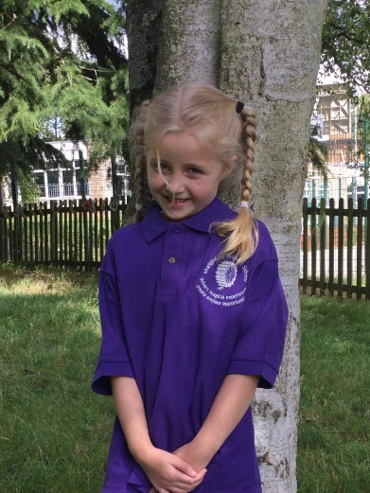
Year 6 PGL UK
Our Year 6 pupils recently returned from an incredible week at PGL Liddington, where they embraced a host of exciting challenges, developed new skills and created unforgettable memories
Throughout the trip, the children demonstrated outstanding teamwork, resilience and determination as they took part in a variety of adventurous outdoor activities. One of the highlights was the Giant Swing, where pupils showed remarkable courage as they soared high into the air, encouraged every step of the way by the cheers of their friends. During the Raft Building challenge, teams combined their communication, problem-solving and teamwork skills to design and build their own rafts before putting them to the test on the water.
Another favourite activity was Jacob's Ladder, which demanded trust, cooperation and perseverance. It was inspiring to watch the children support one another, celebrate each other's successes and encourage everyone to keep going, even when the challenge became more difficult.
The fun continued long after the daytime activities had finished. One evening, the children enjoyed a fantastic Silent Disco. They danced, sang, laughed the night away and created some of the most memorable moments of the week. Whilst the pupils enthusiastically embraced every Taylor Swift classic, Mr Roper was possibly a little less convinced; perhaps he is not yet a ‘Swiftie’!
The week provided countless opportunities for the children to step outside their comfort zones, build confidence and strengthen friendships. We are incredibly proud of the way they represented Madginford Primary School throughout the visit, demonstrating excellent behaviour, kindness, respect and a positive attitude in everything they did.

Year 6 PGL France

Some of our Year 6 children have recently returned from an unforgettable trip to France! During their exciting stay at PGL Château de Grande Romaine, they experienced the adventure of international travel, immersed themselves in French culture, and created memories which will last a lifetime. One of the highlights of the week was the heated outdoor swimming pool, which proved extremely popular, giving the children the opportunity to enjoy several swims throughout their stay.
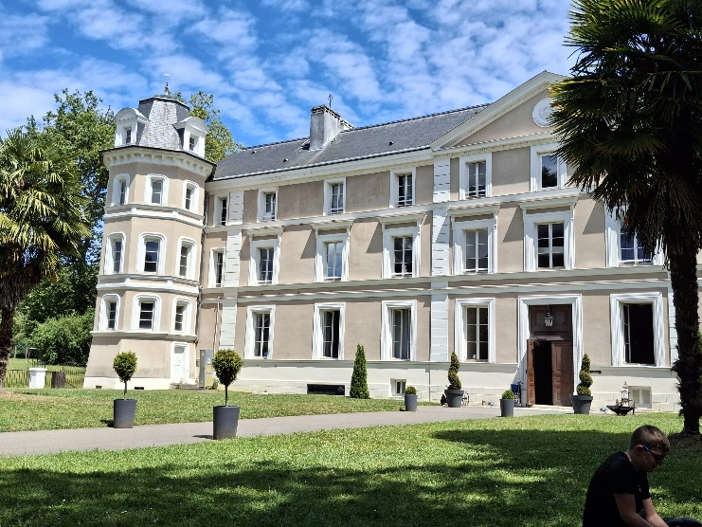
The children also enjoyed an unforgettable day in Paris. They climbed to the second level of the Eiffel Tower, where they took in breathtaking views across the city and spotted many of its famous landmarks. They then embarked on a relaxing boat cruise along the River Seine, passing the beautifully restored Notre-Dame Cathedral and other iconic sights while soaking up the unique Parisian atmosphere.

Later, after a short coach journey, the group visited the charming district of Montmartre and the iconic Sacré-Cœur Basilica. Here, the children had the opportunity to put their French language skills into practice as they bought souvenirs and interacted with local shopkeepers, bringing their classroom learning to life.
After exploring Montmartre and the iconic Sacré-Cœur Basilica, the children enjoyed browsing a local market, where they put their French language skills into practice while choosing souvenirs to take home.
Back at the PGL centre, the adventure continued with a range of exciting activities. Axe throwing proved to be a surprising favourite for many of the children—it certainly turned out to be much harder than it looks!
For many, however, the highlight of the trip was an unforgettable day at Disneyland Paris. The children began their visit in Disneyland Park, where there was something for everyone. Some children tackled thrilling rides such as Hyperspace Mountain, while others enjoyed the park's family attractions. One of the best moments was experiencing Star Tours together as a group, and everyone loved the colourful and energetic parade, despite the soaring temperatures.
The excitement continued at Disney Adventure World, where the children explored the new ‘World of Frozen’ experience and admired the beautiful Kingdom of Arendelle. There were more opportunities for adventure on attractions such as The Twilight Zone Tower of Terror, Avengers Assemble: Flight Force and Spider-Man W.E.B. Adventure. It truly was a magical day filled with unforgettable memories.
On the journey home, the group visited the Vimy Ridge Canadian Memorial and the preserved First World War trenches. This proved to be a particularly moving and thought-provoking experience. Walking through the trenches and seeing just how close the opposing sides were during the conflict gave the children a powerful insight into the realities of the First World War.
Overall, the trip was an unforgettable experience which combined adventure, culture, history and language learning in equal measure. We hope that this trip has provided our Year 6 pupils with memories which will last a lifetime, inspiring confidence, curiosity and a love of travel. For some, it also ignited a passion for learning languages. We are certain that for many of them, this is just the beginning of many more adventures to come!

Pop-Up Pool Coming to Madginford in 2027!
We're excited to share some fantastic news! Next year, we'll be trialling a brand-new way of delivering swimming lessons here at Madginford Primary with our very own pop-up swimming pool.
The pool will be on site for six weeks during Term 3, giving as many children as possible the opportunity to take part. Whether your child is taking their very first steps into the water, building confidence, or is already a capable swimmer looking to develop lifesaving skills and techniques, our qualified swimming instructors and lifeguards will ensure everyone is supported and challenged at the right level.
Although it will be winter outside, there's no need to worry about the temperature! The pool is heated to a comfortable 28°C, and the temporary pool structure is designed to stay warm and welcoming. It also includes individual changing pods, providing children with greater privacy and comfort than traditional group changing rooms.
Swimming is such an important life skill. Not only does it support children's safety around water, but it's also a fantastic way to stay active, improve fitness, and enjoy a sport that can be both fun and relaxing. We want every child to leave Madginford as a confident swimmer, and we're delighted to be able to offer this exciting opportunity to help achieve that goal.
Keep an eye on the Olympic Zone as it's transformed into our very own Olympic Swimming Pool Zone – we can't wait to make a splash!

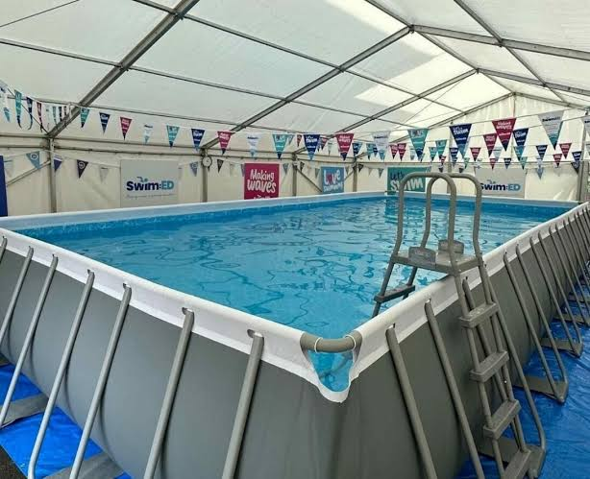

School Improvement Priorities 2025–26
To be excellent readers
To provide a wide and ambitious curriculum that engages all learners All children to recognise and celebrate their success

✨ Every Day Counts — Let the Magic Happen at Madginford! ✨
At Madginford, we believe every child deserves magical learning experiences — and those moments happen when children are in school, on time, every day.

Regular attendance helps children feel confident, settled, and ready to enjoy everything school life has to offer.

🪄 Did you know?

- Missing school regularly can make it harder for children to keep up with learning and friendships.
- Being late can be just as disruptive as being absent. Lateness after the registers close becomes an unauthorised absence.
- Missing 10% of school (around 2 days each month) can impact progress in reading, writing, and maths.

Small absences can quickly add up — and we don’t want anyone to miss all the important learning and experiences!

💜 Why being here matters

Children who attend school regularly are more likely to:

- Feel happy, confident, and secure
- Build strong friendships
- Enjoy learning and reach their full potential

Every school day brings new opportunities for magical moments of learning.

🎒 How families can help

You can support great attendance by:

- ⏰ Keeping a regular bedtime and morning routine
- 👕 Preparing uniforms, book bags, and PE kits the night before
- 🚶 Having a backup plan for getting to school if something unexpected happens
- 🦷 Booking medical and dental appointments outside school hours where possible
- 👀 Keeping an eye on your child’s attendance
- 💬 Talking to the class teacher or school staff if your child feels worried or anxious; we’re always here to help

📅 Attendance reminder

Persistent absence means missing 10% or more of the school year — around 19 days. That’s why every day really does count.

🌟 Working together

If your child is unwell or you’re unsure whether they should attend, please contact the school office. By working together, we can make sure every child feels supported and ready to enjoy the magic of learning at Madginford.

Be here. Be ready. Be part of the magic. 💜✨

Communication Reminder
If you have any concerns, please first contact your child’s class teacher. If needed, you may then reach out to the Head of Year:
- EYFS: Mrs. South & Miss Perkins
- Year 1: Miss Verkely
- Year 2: Mr. Bevan
- Year 3: Mrs. Cross
- Year 4: Mrs. Ralph & Mr. Day
- Year 5: Mr. Hollamby
- Year 6: Mr. Roper

For ongoing concerns, please contact:
  - Mrs. Best – Assistant Head (EYFS/KS1)
  - Miss Stamp – Assistant Head (KS2)
  - Mrs. Woolcombe – Headteacher
We are always here to help.

Key Dates for Your Diary

Friday 10th July- NEW date for Sports Day

Tuesday 14th July- NEW date for Y6 Evening Production for parents

Wednesday 15th July- NEW date for Y6 Evening Production for parents

Wednesday 15th July- Rocksteady Concert for Parents

Wednesday 15th July- EYFS Meet the new teachers (3:10PM)

Wednesday 15th July- Years 1-6 Meet the new Teachers and view the new classrooms (3:30PM-4:00PM)

Friday 17th July- Rocksteady Concert for Parents

Friday 17th July- Y6 Leavers Prom (subject to change)

Monday 20th July- Y6 Graduation

Thank you for your ongoing support. We look forward to updating you even more exciting achievements as we continue through Term 6.
Warm regards, Mrs. A. Woolcombe Headteacher
Madginford Primary School • Inspiring learning for life

