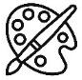
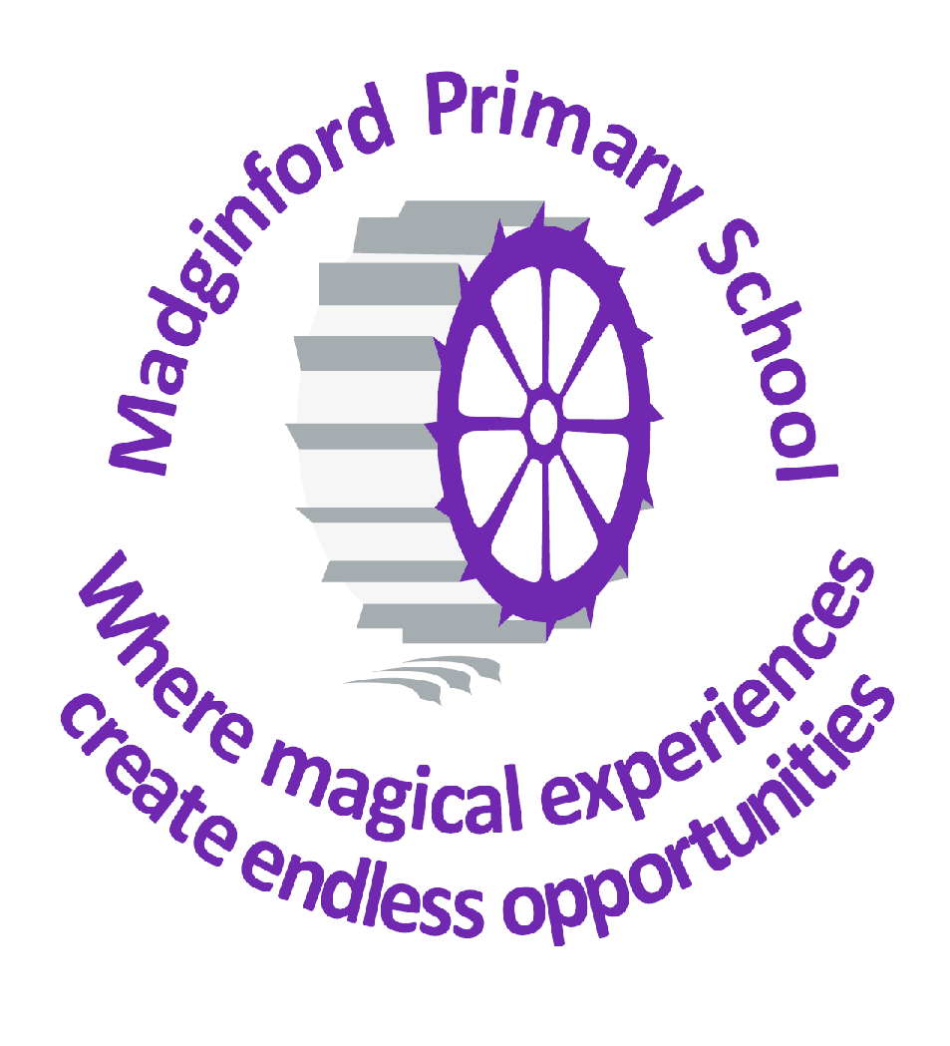
Art at Madginford Primary School

 | Autumn | Spring | Summer
EYFS | - Drawing: experimenting with mark making  - Mixing primary colours  - Collage: ripping, tearing & exploring textures  - Experimenting with media: watercolours, chalk pastels, pencils, pens  - Printing with everyday objects  - Construction & model-making
Y1 | Colour, Colour Everywhere  Get to know the colour wheel & explore how to make those amazing autumn colours. Use leaves & other found objects to create colourful autumn prints. | Burning Brightly  Explore the colours & textures we can create when we experiment with different papers & media. We’ll learn what a silhouette is when creating our own versions of ‘Great Fire of London’ masterpieces. | The Art of Tinga Tinga  Play with colour & pattern as we explore the vibrant art of Edward Tinga Tinga. Create amazing skyscapes and our own clay tiles to recreate our favourite paintings.
Y2 | The Art of Alma Thomas  We’ll explore the wonderful world of colour. Taking inspiration from the works of Alma Thomas & the colourful world around us, we’ll learn how to make colours & create our own artworks | Going in Circles  We’ll explore the work of Kandinsky, experimenting with different materials to create circle collages before going on to set up our own simple, circular looms for some amazing weaving. | The Wonderful World of Disney  Explore some of the artworks that inspired the animations of the Walt Disney studios. Inspired by the work of Mary Blair, we’ll create our own fantasy castles.
Y3 | The Art of Yayoi Kusuma  Inspired by the artworks of Yayoi Kusuma, children will create their own ‘dotty’ pumpkins before creating colourful clay pots based on their artworks | The Treasures of Ancient Egypt  The craftworkers & designers of Ancient Egypt left us some amazing treasures! Children create simple sketches of these artefacts which they then turn into monoprints | Very, very tasty!  The paintings of Wayne Thiebaud are very tasty! Children explore the artworks showing cakes, ice-cream & other tasty treats before using their understanding of colour & shape to create their own versions.
Y4 | Mosaics  The Romans left us with lots of fantastic mosaics. Children create their own paintings of fruit before using art programs to turn their designs digital! | The Designs of Clarice Cliff  The designs of ceramics artist Clarice Cliff are vibrant pieces of art guaranteed to cheer you up. Children experiment with her style to create paintings of our school grounds. | Look Out!  Our eyes help us to see the world around us. They show if we are happy, sad or even tired. Y4 will explore how to use their skills to draw both human and reptile eyes, using pencils and chalks.
Y5 | Exploring Faces  Inspired by the artwork of Julian Opie, children paint their own self-portraits. They then experiment with ‘drawing with scissors’, creating other portraits using collage in the style of Maria Rivans. | The Designs of the Maya  Children sketch a mask inspired by those of the Ancient Maya. They use pressprint to create a tile version of their mask before experimenting with pattern & colour. They will then complete an abstract piece based on the glyphs of the Maya using pen and paint. | Local Landmarks!  Children will sketch & draw landmarks to tell the story of our local area, developing their knowledge & understanding of perspective.
Y6 | A Matchstick Christmas  Inspired by the artwork of L.S. Lowry, children use his colour palette to create their own watercolour Christmas cards. | Bigger is Better  Children use macro lenses to explore the natural world. Drawing on their drawing skills, children explore the use of space to create close-up paintings | Memories!  Choosing how to present their favourite memories, children use a wide range of materials to create their own memento of their time at school

