Art at Madginford Primary School

What children need to know & experience by the end of the year | The artists & artworks children will learn about include:  1
Drawing (Gathering Ideas)  - Experiment with mark-making in sketch books  - Make lines: straight, wavy, curved, zigzags, spirals, broken, criss-cross  - Experiment with tone: light, dark, soft, gentle, hard  - Experiment with different media: HB, B pencils, chalks, charcoal  Drawing (Mastering Techniques)  - Use HB & B pencils  - Press lightly: introduce “draw it light ‘til it’s right!”  - Understand how to use ‘shading’ grip – hold the pencil to use the side of  - the point  - Know how to make sure colour is even (use pencil grip, move page)  - Look for shapes in an object – use shapes to help draw an object  Understanding Colour  - Mix primary colours  - Explore how colours make us feel  - Create shades using black and white  - Use different sized brushes  - Know how to care for brushes  - Choosing and using different brushes  - Understand that different paint can be used for different effects  Printing  - Print using found objects  - Know how to apply paint effectively  - Experiment with patterns  Collage  - Experiment with ripping and tearing  - Experiment with different textures  - Choosing the best colour for the task  Clay  - Explore how to manipulate and shape  - Use objects to add marks and decorate | 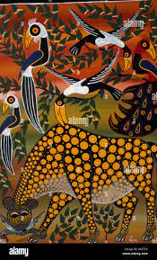  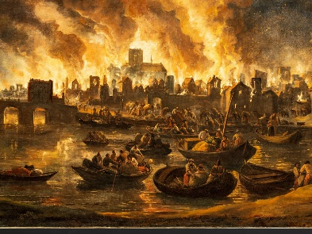  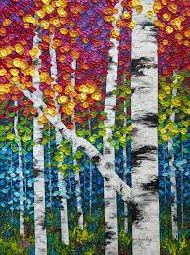  1 2 3  1.Melissa McKinnon (Vibrant Autumn)  2.The Great Fire of London in 1666: Lieve Verschuier  Fir Brit London Great Fire 1666 — Google Arts & Culture  3. Edward Tingatinga
 | The vocabulary children need to know & use includes:
- HB, B – hardness of pencil lead
- Shading
- Tone: light, dark
- Line: straight, wavy, curved, zigzags, spirals, broken, criss-cross
- Chalk
- Charcoal
- Mix
- Shade
- Print
- Ripping / tearing
- Texture
Art at Madginford Primary School

What children need to know & experience by the end of the year | The artists & artworks children will learn about include:  2
Drawing (Gathering Ideas)  - Use viewfinders to focus observations & shapes to add details to drawings  - Experiment with different types of lines  - Experiment with different media – express likes/dislikes  - Explore language: tone, line, sketch, blending, shadows  Drawing (Mastering Techniques)  - Use different gradients of pencils (HB, 2B, 4B)  - Knows & uses “draw it light ‘til it’s right!” when generating sketches &  - drawing  - Uses ‘shading’ grip  - Makes sure colour is even (directionality of stroke, even coverage)  - Uses shapes to create guidelines for drawings  - With adult help, adds light/dark to a sketch (experiment with blending)  Understanding Colour  - Be able to match colours  - Know, name and make secondary colours  - Mix colours to create tints and shades  - Matching colours by mixing with powder paint, watercolours etc.  Collage  - Experiment with different textures and techniques  - Have a knowledge of the colour wheel to choose the best colour for a task  - Create a photomontage  Textiles  - Paper weaving  - Create a circular loom by experimenting with wool, ribbons & fabric  Printing  - Use found objects to print in the style of an artist  - Know how to manage amounts of paint to make sure of clear, crisp shapes  Digital Art  - Know how to take an effective photograph with specifics on focus, the viewfinder, light and positioning  - Create a simple photomontage | 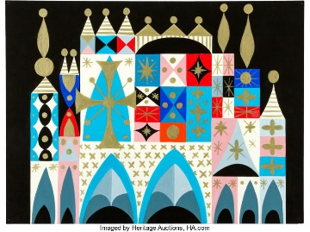  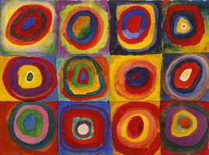  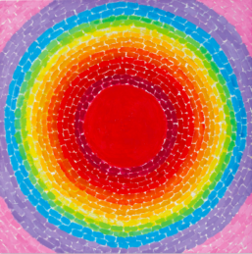  1 2 3  - Work of Alma Thomas (A Fantastic Sunset)  - Wassily Kandinsky (Squares with Concentric Circles)  - Mary Blair (It’s a Small World)  The vocabulary children need to know & use includes:  - Sketch  - Gradient  - Shading grip  - Directionality – colour in the same direction  - Coverage – colour looks the same all over space (no white etc)  - Tone: light, dark, shadow  - Primary and Secondary  - Tint and shade  - Ripping and tearing  - Texture  - Photomontage  - Weaving  - Focus, viewfinder, light, positioning

Art at Madginford Primary School
3

What children need to know & experience by the end of the year | The artists & artworks children will learn about include:
Drawing (Gathering Ideas)  - Annotate practice shapes: what went well? What needs practice? Things to  - remember?  - Use vocabulary – create word banks to support discussion of drawing  - Experiment with different gradients of pencil – explore amount of pressure  - needed to create darkest/lightest colours on a sketch  - Develop technical language when talking about drawing  Drawing (Mastering Techniques)  - Draw cubes & cylinders  - Know where the light is coming from – identify where the darkest & lightest  - parts of the drawing will be  - Use shading grip to control the darkest & lightest parts of the drawing  - Blend pencils to create shadows & to avoid harsh lines  - Look for & recognise use of shapes in everyday objects  - Use 2D/3D shapes as guidelines for creating sketches  Painting  - Experiment with different brush techniques  - Controlled mark making using brushes for even coverage  - Apply different textures and effects with paint  Understanding Colour  - Understand and explain primary and secondary colours. Experiment with tertiary colours  - Know about warm and cool, and harmonious and contrasting colours  - Use black and white to create shades and tints  - Use appropriate vocabulary to describe and explain mixing colours  - Create tone by adding grey  Printing  - Create a design for printing using simplified sketches  - Understand, use and create monoprint  - Explore sketching techniques to add detail to monoprint  3D Work  - Experiment with clay, manipulating to shape  - Explore different thicknesses of clay  - Join clay  - Select appropriate objects to add detail  - Choose and apply colour carefully | - Yayoi Kusama  - Wayne Thiebaud  - Crafts people & designers of Ancient Egypt  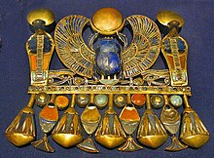  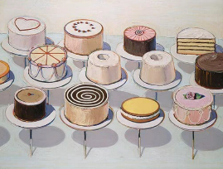  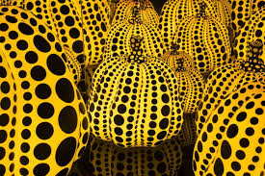  1 2 3  The vocabulary children need to know & use includes:  - Light source  - Shadow  - Guidelines  - Sketch – draw it light ‘til it’s right!  - Drawing – more detailed, final artwork  - Primary, secondary and tertiary  - Warm, cool, harmonious, contrasting colours  - Shade and tint  - Tone  - Sketch  - Monoprint  - Manipulate
Art at Madginford Primary School

What children need to know & experience by the end of the year | The artists & artworks children will learn about include:  4
Drawing (Gathering Ideas)  - Annotate practice shapes: what went well? What needs practice?  - Use vocabulary – create word banks to support discussion of drawing  - Experiment with different gradients of pencil – explore amount of pressure needed to create darkest/lightest colours on a sketch  - Develop technical language when talking about drawing  Drawing (Mastering Techniques)  - Draw cubes, cylinders & spheres  - Identify the light source & indicate where lightest & darkest part of the shape will be.  - Draw 2 or more 3D shapes together – think about perspective  - Use lines to add detail (dots, dashes, hatching, cross-hatching) to shapes  - Use 3D shapes as guidelines to draw 3D objects  Painting  - Select different brush techniques for shape, texture, pattern and line  - Use an appropriate brush to ensure even coverage of colour  - Experiment with and create different textures and effects with paint  Understanding Colour  - Confidently explain the colour wheel and primary, secondary and tertiary colours  - Explain warm and cool and harmonious and contrasting colours  - Use black and white effectively to create shades and tints  - Mix different medias to create tone by adding grey  Textiles  - Explore weaving on a small loom practising under and over techniques using wool and thread  - Experiment with colours & textures  - Know how to join and tie threads  - Add simple embellishments  Collage  - Choose colours to represent fruits & vegetables  - Experiment with ways to add shading & detail through choice of paper  - Cut & shape paper tiles to complete design | - Roman Mosaic  - Clarice Cliff  - Catherine Hyde (illustrator – The Princess’ Blankets)  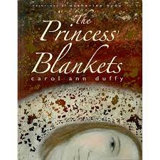  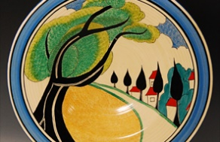  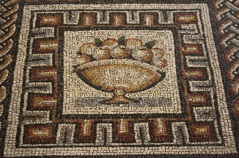  1 2 3  The vocabulary children need to know & use includes:  - Perspective  - Positioning  - Hatching / cross-hatching  - Guidelines  - Shape, texture, pattern, line  - Coverage  - Primary, secondary, tertiary  - Warm, cool, harmonious, contrasting colours  - Shade and tint  - Tone  - Weaving  - Under and over technique  - Copy, paste, rotate  - Depth  - Mosaic  - Shadows & light source
Art at Madginford Primary School

The artists & artworks children will learn about include:
5
Drawing (Gathering Ideas)  - Annotate practice shapes: what went well? What needs practice?  - Use vocabulary – create word banks to support discussion of drawing  - Continuous line drawing  - Blind drawing  Drawing (Mastering Techniques)  - Create simple still-life using 3 or more objects; think about placement, lightest & darkest parts of the drawing  - Use lines & other marks to add detail to artwork  - Choose the best gradient of pencil to add depth & detail to a sketch  - Draw 3D shapes from different viewpoints – eye-level, above eye-level or below eye-level  - Know & understand the term 1-point perspective  Painting  - Independently choose the best brush for the task  - Use a range of brushes to create textures and patterns  - Choose the type of paint best suited for the task  - Demonstrate an understanding of techniques used by artists and apply these in their own work  Understanding Colour  - Mix colours confidently  - Know what is meant by ‘colour palette’  - Use a colour palette to create their own artwork  - Choose colours to create feelings and emotions within a piece of art  Printing  - Create a design for printing  - Design a relief printing block and shape this to reflect their design  - Understand and use ‘print motif’  - Use printing inks and rollers to create sharp images  - Experiment with colour and positioning of design to create a repeated pattern  - Create multi-layered prints on different texture | - The portraits of Julian Opie & collages of Maria Rivans  - The prints of William Morris  - Local landmarks (Bearsted/ Maidstone area)  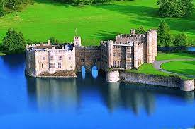  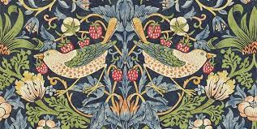  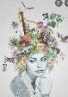  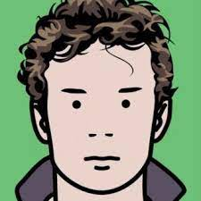  The vocabulary children need to know & use includes:  - Perspective  - Horizon  - Vanishing point  - Eye-level  - Colour palette  - Relief printing block  - Print motif  - Sharp image  - Cut, shape, join  - Raised relief
 | What children need to know & experience by the end of the year
Collage
- Explore the work of the artist Maria Rivans
- Create a simple sketch to show ideas for a self-portrait in the style of Rivans
- Collect images from a variety of sources
- Explore layout and organisation of motifs
- Create a collage
- Make comparisons with others’ artwork in the year group

3D Work
- Create a design based on a real-life location
- Use tools and equipment to cut and shape tiles
- Use tools to join clay securely, smooth clay and add decoration
- Add details in raised relief
- Add clay to make the tile freestanding
- Add colour to complete the design

Art at Madginford Primary School

What children need to know & experience by the end of the year | The artists & artworks children will learn about include:  6
Drawing (Gathering Ideas)  - Annotate practice shapes: what went well? What needs practice?  - Use vocabulary – create word banks to support discussion of drawing  - Continuous line drawing  - Blind drawing  Drawing (Mastering Techniques)  - Create simple still-life using 3 or more objects; think about placement, lightest & darkest parts of the drawing  - Use lines & other marks to add detail to artwork  - Choose the best gradient of pencil to add depth & detail to a sketch  - Draw 3D shapes from different viewpoints – eye-level, above eye-level or below eye-level  - Know & understand the term 1-point perspective  Painting  - Independently choose the best brush for the task  - Use a range of brushes to create textures and patterns  - Choose the type of paint best suited for the task and explain why  - Demonstrate an understanding of techniques used by artists and apply these in their own work  Understanding Colour  - Mix colours confidently, using appropriate vocabulary  - Know and confidently explain what is meant by ‘colour palette’  - Use a colour palette to create their own artwork  - Choose colours to create feelings and emotions within a piece of art  Digital Art  - Experiment with photographic techniques: use of space, composition, changing levels  - Use macro lenses and explore how usual techniques work  - Take macro photos of classroom objects | - L.S.Lowry  - Georgia O’Keeffe  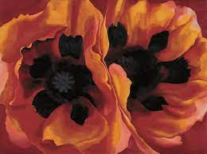  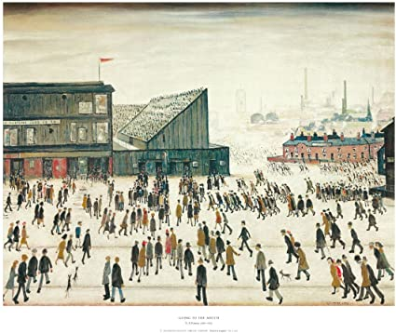  1 2  The vocabulary children need to know & use includes:  - Inks  - Observation  - Bird’s/worm’s eye view  - Colour palette  - Space, composition, changing levels  - Macro lens/photo

